TEACHER:MWALE CHIPO

KENNETH KAUNDA SECONDARY SCHOOL DESIGN AND TECHNOLOGY DEPARTMENT
LESSON PLAN

SUBJECT: DESIGN AND TECHNOLOGY CLASS:…… … DATE:……/……./20…. DURATION:………….
BOYS:…………………… GIRLS ………………………………………. TOTAL OF PUPILS… TOPIC: CIRCLE SUBTOPIC: CIRCLE
LEARNING OUTCOMES LSBAT
- Identify parts of a circle
RATIONALE
Knowledge: Parts of a circle

Skills: Interpretation of methods of constructing circles
Values: Appreciation of constructing circles accurately
TEACHING AIDS……………………………………………………………………………………………………………….
PART | LESSON CONTENT | METHODOL OGY | LEARNER ACTIVITY
introducti on | - Recap on the previous lesson | Questions and answers | Provide answers
Develop ment | CIRCLE  PARTS OF A CIRCLE  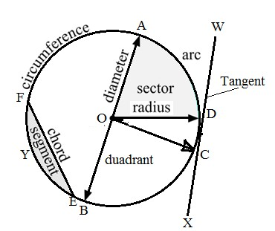  RADIUS (OD)  - The distance from the middle of the circle to the circumference of the circle  DIAMETER (AB)  - The distance across a circle through the centre (twice the radius).  ARC (AD)  - The part of the circumference between 2 radii  CIRCUMFERENCE (A,D,C,B, E,F,A)  - The boundary line or perimeter of a circle  CHORD (EF)  - A line segment that joins two points on the circumference, but not passing through the centre  TANGENT (WX)  - a straight line touching the circumference of any particular point and drawn at right angle to the normal which passes through that point  SECTOR (AOD)  - The part of a circle between 2 radii.  QUADRANT(BOC)  - Quarter of a circle or a quarter of its circumference  SEGMENT (FEY)  - The part of a circle that is between a chord and the circumference
Applicati on | CLASS EXERCISE  1. Draw and label 9 parts of a circle | Questions And Answers | Provide answers
Conclusi on | - Recap on the main steps and points | V/E

TEACHER:MWALE CHIPO

KENNETH KAUNDA SECONDARY SCHOOL DESIGN AND TECHNOLOGY DEPARTMENT
LESSON PLAN

SUBJECT: DESIGN AND TECHNOLOGY CLASS:…… … DATE:……/……./20…. DURATION:………….
BOYS:…………………… GIRLS ………………………………………. TOTAL OF PUPILS…
TOPIC: CIRCLE SUBTOPIC: CONSTRUCTION CIRCLE
LEARNING OUTCOMES LSBAT
- Construct a circle of given radius and diameter
RATIONALE

Knowledge: Construction of circles given radius and diameter. Skills: Interpretation of methods of constructing circles Values: Appreciation of constructing circles accurately
TEACHING AIDS……………………………………………………………………………………………………………….
PART | LESSON CONTENT | METHODOL OGY | LEARNER ACTIVITY
introducti on | - Recap on the previous lesson | Questions and answers | Provide answers
Develop ment | CIRCLE CONSTRUCTION OF CIRCLE  To construct the circle given the radius 30 mm  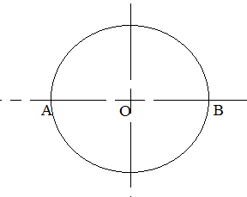  Radius AO = OB =30mm  To construct a circle to pass through three given points  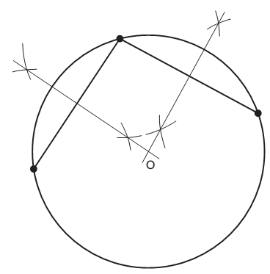  - Draw straight lines connecting the points as shown. These lines are, in fact, chords of the circle.  - Draw perpendicular bisectors through these lines to intersect in O. O is the centre of a circle that passes through all three points.
Applicati on | CLASS EXERCISE  Construct the following circle  - Given that the diameter of the circle is 70mm  - Given that radius of the circle is 25mm | Questions And Answers | Provide answers
Conclusi on | - Recap on the main steps and points | V/E

TEACHER:MWALE CHIPO

KENNETH KAUNDA SECONDARY SCHOOL DESIGN AND TECHNOLOGY DEPARTMENT
LESSON PLAN

SUBJECT: DESIGN AND TECHNOLOGY CLASS:…… … DATE:……/……./20…. DURATION:………….
BOYS:…………………… GIRLS ………………………………………. TOTAL OF PUPILS…
TOPIC: CIRCLES SUBTOPIC: CIRCUMSCRIBING AND T INSCRIBING RIANGLES,
LEARNING OUTCOMES LSBAT
- Define the following terms Circumscribing, Inscribing And Escribed
- Construct circumscribed and inscribed Triangles.
RATIONALE

Knowledge: Escribed triangles, Circumscribing and inscribing circle to triangles.
Skills: Interpretation of methods of constructing circles Values: Appreciation of constructing circles accurately TEACHING AIDS
PART | LESSON CONTENT | METHODOLO GY | LEARNER ACTIVITY
Introduction | - Recap on the previous lesson | Questions and answers | Provide answers
Developme nt | CIRCUMSCRIBING  - Circle whose circumference passes through all the corners of the given triangle  To construct the circumscribed circle to a given triangle ABC, AB=56, AC=52, BC=48  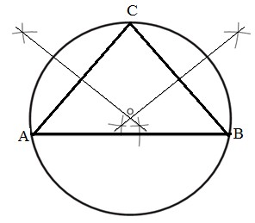  - Draw the given triangle ABC using the above data  - Perpendicularly bisect any two sides to intersect in O  - O is the centre of the circumscribed circle  INSCRIBING  - Circle drawn inside a given triangle which touches all the three sides of the given triangle  To construct the inscribed circle to a given triangle ABC, AB 60, BC=50 AC=45.  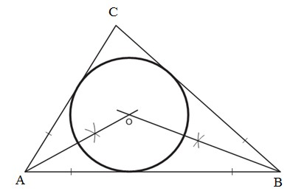  - Draw the given triangle ABC using the above data  - Bisect any two of the interior angles to intersect in O  - O is the centre of the inscribed circle
Application | CLASS EXERCISE  - Construct the triangle given that AB=70, BC= 80,  AC=60  - Circumscribe the triangle  - Inscribed the triangle | Questions And Answers | Provide answers
Conclusion | - Recap on the main steps and points | V/E

TEACHER:MWALE CHIPO

KENNETH KAUNDA SECONDARY SCHOOL DESIGN AND TECHNOLOGY DEPARTMENT
LESSON PLAN

SUBJECT: DESIGN AND TECHNOLOGY CLASS:…… … DATE:……/……./20…. DURATION:………….
BOYS:…………………… GIRLS ………………………………………. TOTAL OF PUPILS…
TOPIC: CIRCLES SUBTOPIC: CIRCUMSCRIBING, INSCRIBING AND ESCRIBED TRIANGLES,
LEARNING OUTCOMES LSBAT
- Define Escribed triangle
- Construct circumscribed, inscribed and Escribed triangles.
RATIONALE
Knowledge: Escribed triangles,
Skills: Interpretation of methods of constructing circles Values: Appreciation of constructing circles accurately TEACHING AIDS
PART | LESSON CONTENT | METHODO LOGY | LEARNER ACTIVITY
introduction | - Recap on the previous lesson | Questions and answers | Provide answers
Developme nt | ESCRIBED  - Circle drawn outside a given triangle whose circumference will be tangential to one side of the triangle and tangential to two other adjacent sides of a triangle when extended  To construct the escribed circle to a given triangle AB 60, BC=50 AC=45  - Draw the given triangle ABC using the above data.  - Bisect the exterior angles thus formed to intersect in O.  - O is the centre of the escribed circle.  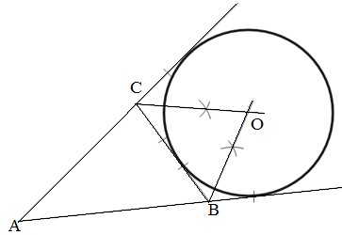 | Questions And Answers  Demonstrati on  V/E | Taking note of important points  Provide answers
Application | CLASS EXERCISE  1. Construct the triangle given that AB=70, BC= 80, AC=60  c. Escribed triangle  HOME WORK  You are required to draw the figure full size showing all construction lines necessary to ensure the circles are tangential to their adjacent lines.  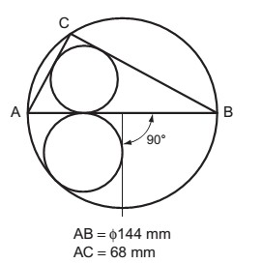 | Questions And Answers | Provide answers
Conclusion | - Recap on the main steps and points | V/E

TEACHER:MWALE CHIPO.

KENNETH KAUNDA SECONDARY SCHOOL DESIGN AND TECHNOLOGY DEPARTMENT
LESSON PLAN

SUBJECT: DESIGN AND TECHNOLOGY CLASS:…… … DATE:……/……./20…. DURATION:………….
BOYS:…………………… GIRLS ………………………………………. TOTAL OF PUPILS… TOPIC: CIRCLES SUBTOPIC: ECCENTRIC AND CONCENTRIC CIRCLES LEARNING OUTCOMES LSBAT
- Construct eccentric and concentric circles
RATIONALE

Knowledge: Construction of eccentric and concentric circles given radius and diameter.
Skills: Interpretation of methods of constructing circles Values: Appreciation of constructing circles accurately TEACHING AIDS
……………………………………………………………………………………………………………………………………………

PART | LESSON CONTENT | METHODOLO GY | LEARNER ACTIVITY
introduction | - Recap on the previous lesson | Questions and answers | Provide answers
Developme nt | CIRCLES  TYPES OF CIRCLES  CONCENTRIC CIRCLE  Concentric circles are circles with a common centre  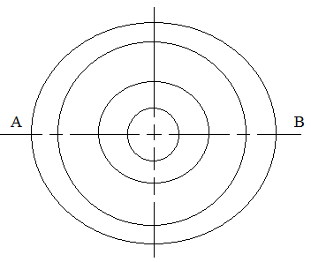  ECCENTRIC CIRCLES  Eccentric circle have different centres  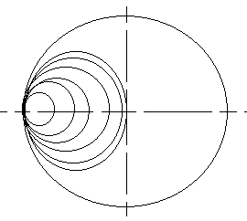 | Questions And Answers  Demonstration  V/E | Taking note of important points  Provide answers
Application | CLASS EXERCISE  Draw the following circles  - Eccentric circle diameter 70mm  - Concentric circle diameter 70mm | Questions And Answers | Provide answers
Conclusion | - Recap on the main steps and points | V/E

LESSON EVALUATION

